## Problem #1 (warm-up): generate the red and blue checkboard image

The number of grid is 6 by 6, result is shown below, refer Appendix P1 for code.

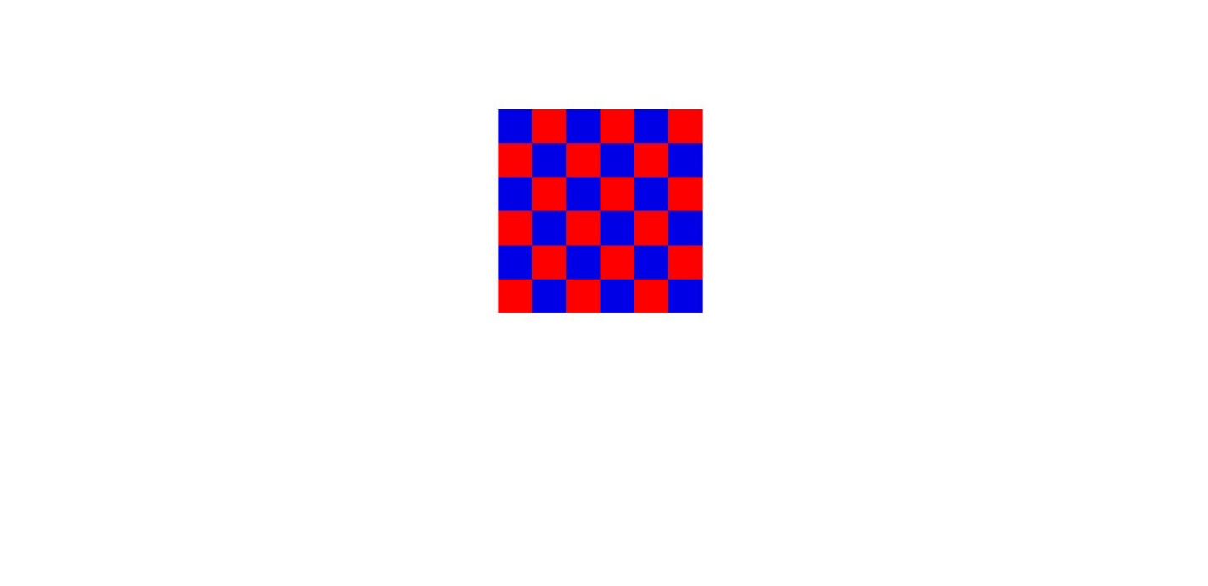

## Problem #2: perform mean, median and gaussian filtering for a given image “part.png” with sizes 3x3, 11x11 and 31x31.

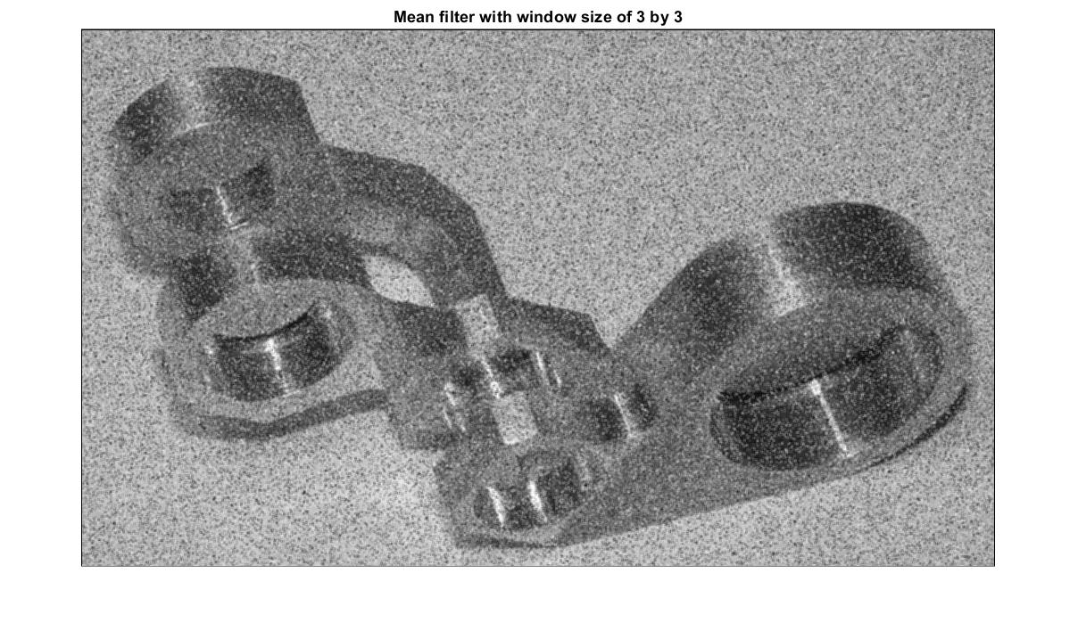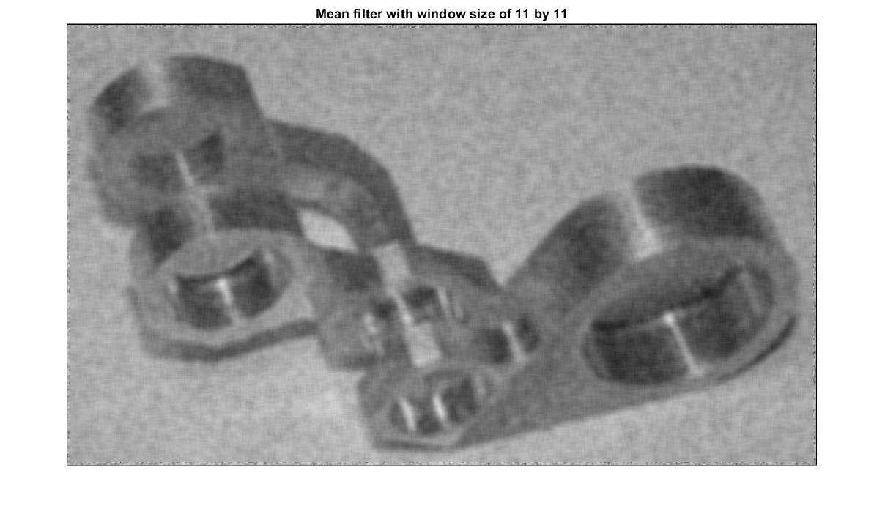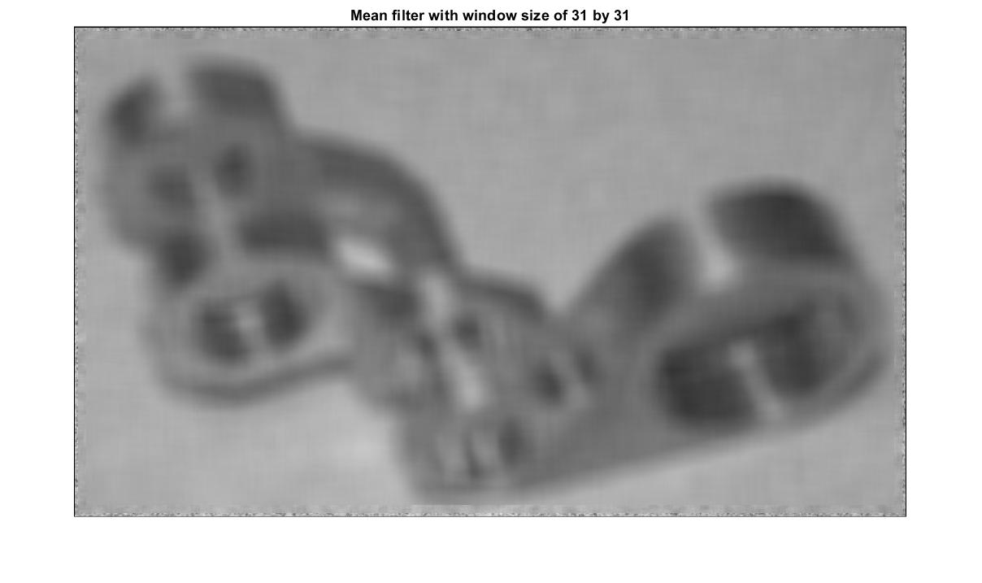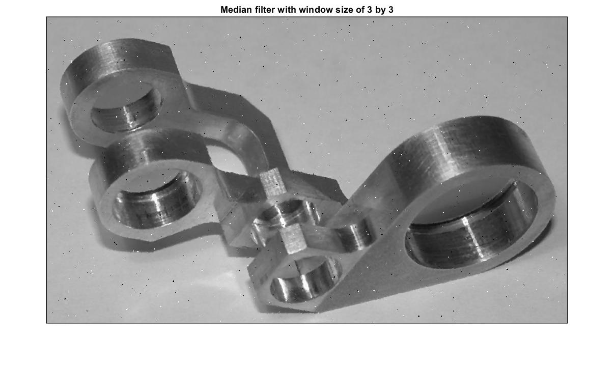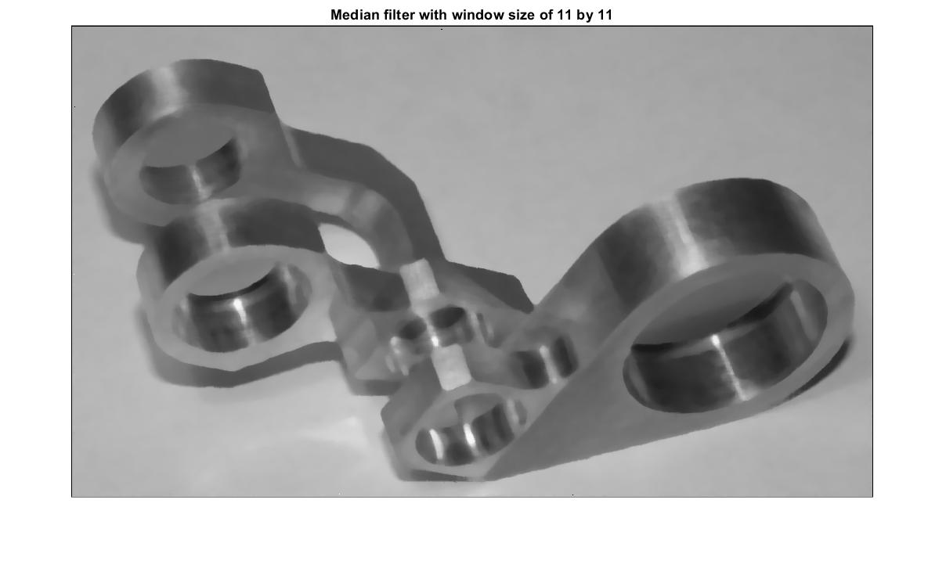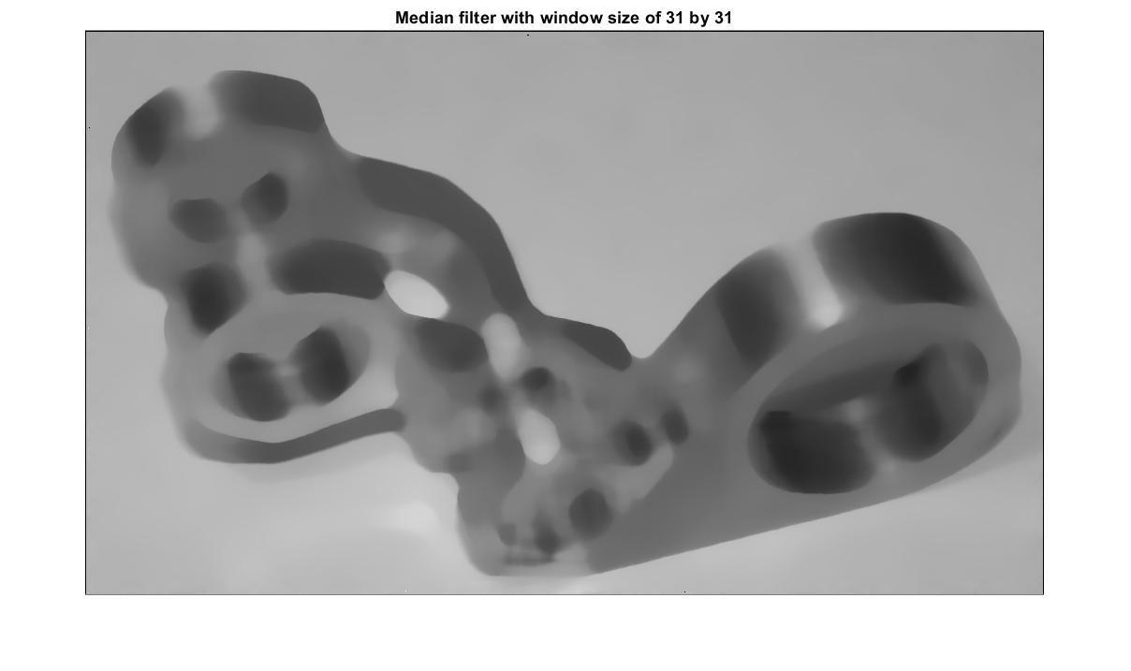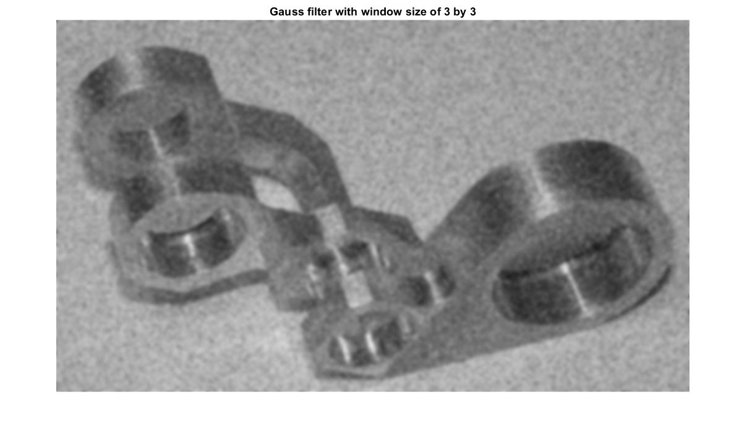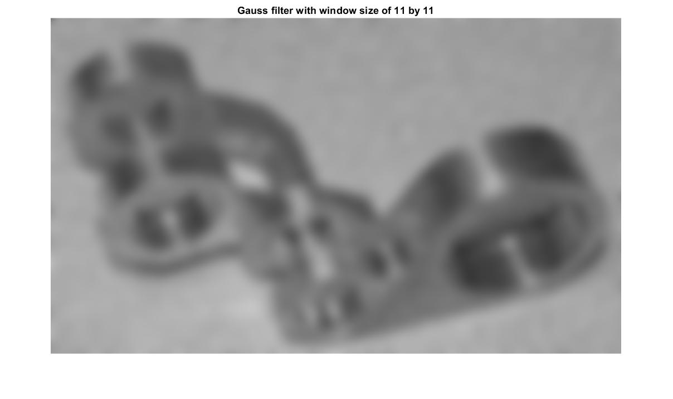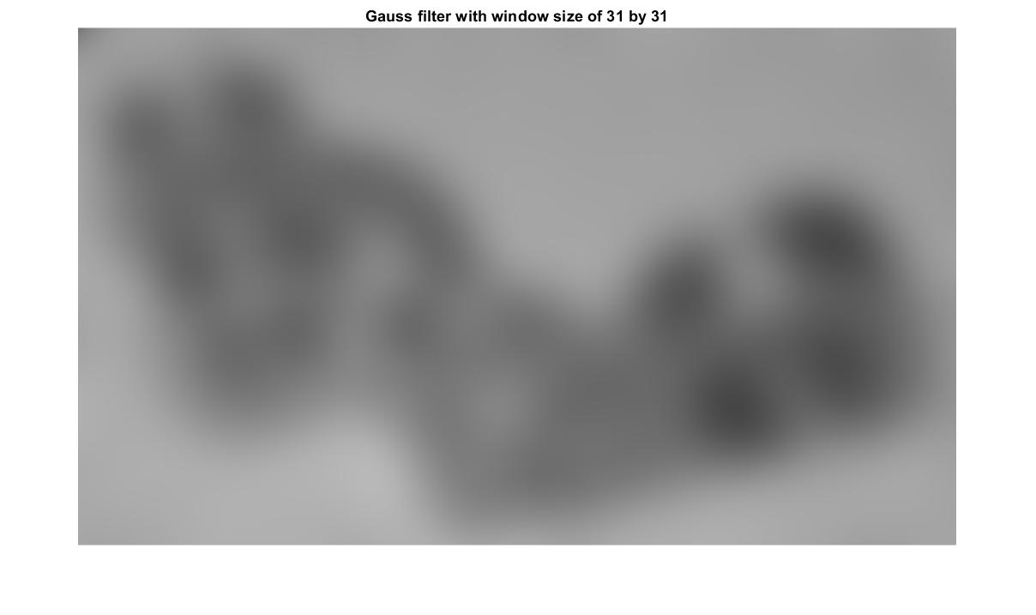

## Problem #3 – demonstrate the edge shift of a 3x3, 11x11 and 31x31 median filer using matlab plots, test with “SquareCircle.png”.

## 

## 

## Problem 4 (open ended question): Filter noises using a combination of any filters you prefer to ensure that you have reasoning behind it.

The noisy Lena picture has random scattered speckles over the whole picture, based on the experience from problem #2, the median filter is suitable for this situation. The resultant image and intensity analysis are shown below.

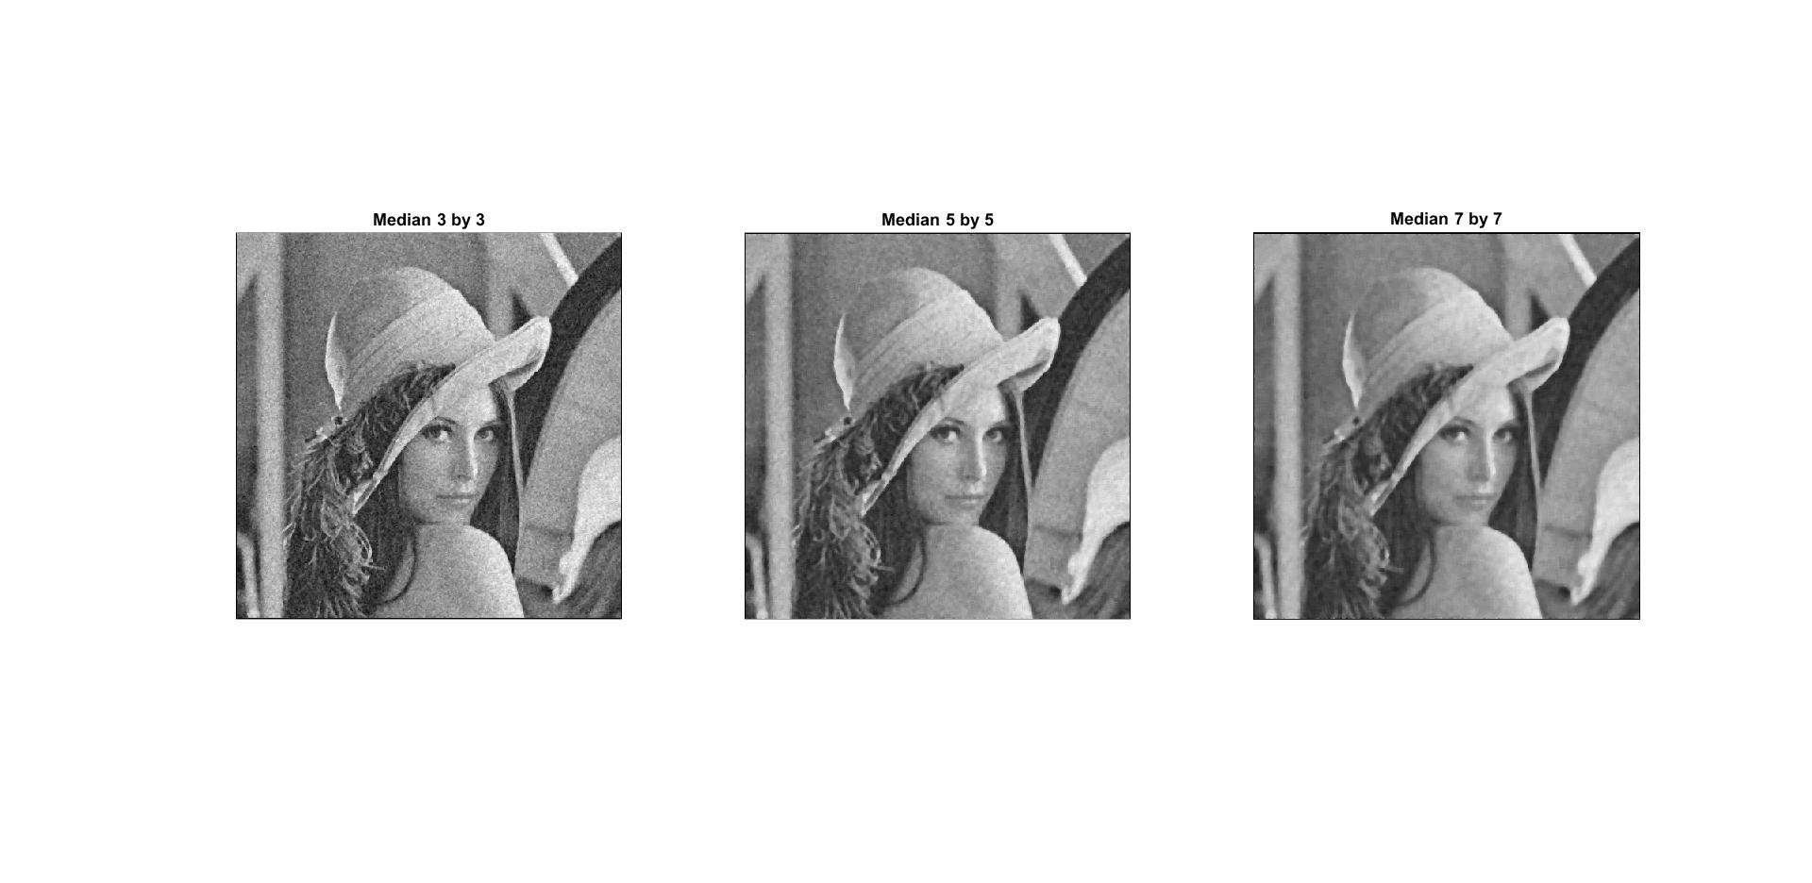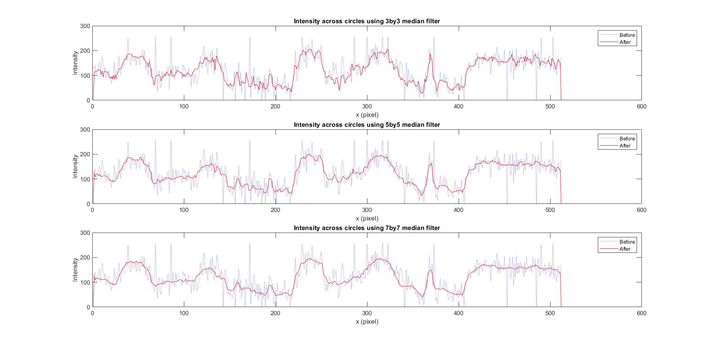

From the intensity plot above, the 3x3 median filter doesn’t eliminate some shape changes made by speckles, where the intensity of the dot bigger than 200. However, the 5x5 median filter gets rid of the noise effect better, and in the meanwhile, preserve the natural characteristics of the image.

After mitigating the noise, an enhancement filter can be applied to sharp the image. A resultant image and intensity plot shows below.

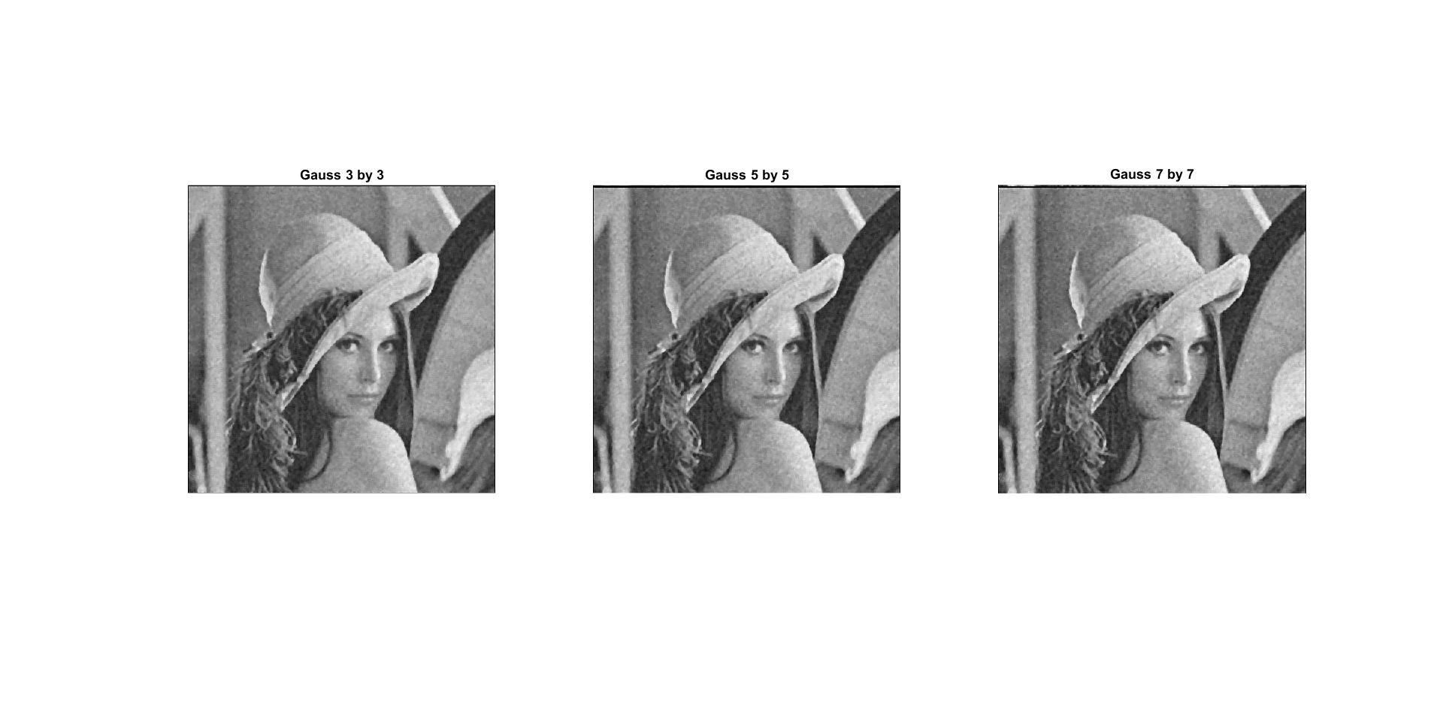

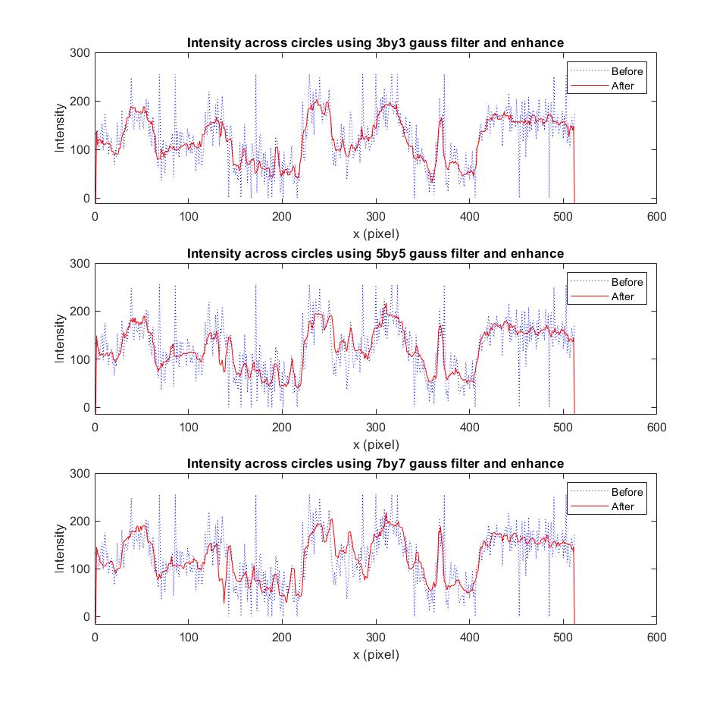

The conclusion a combination of 5 by 5 median filter and 7 by 7 enhancement will mitigate and restore the original image.